CpE 111 Homework Assignment #6 Maximum – 100pts

HW#6 is due at the beginning of class on Mar 23, 2007. You must always show or explain your work in a neat and orderly format. You are encouraged to discuss ideas with other students and consult references but your work must be your own.

1. Draw CMOS logic gates for a 4-input NAND gate and a 3-input NOR gate. (10pts)

2. Design a CMOS cascade that has an output of

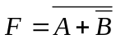

using CMOS NOT and NOR gates as primitive building blocks. (15pts)

3. Design a CMOS logic gate that will implement the function in AOI form shown below. (15pts)

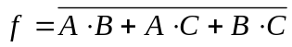

4. Design a CMOS logic circuit for the function

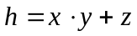

by using an AOI gate cascaded into an inverter. (15pts)

5. Design a CMOS logic gate that will implement the function in OAI form shown below. (15pts)

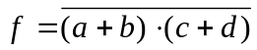

6. Consider the following truth table where A, B and C are inputs and F is output:

A | B | C | F
0 | 0 | 0 | 1
0 | 0 | 1 | 1
0 | 1 | 0 | 1
0 | 1 | 1 | 0
1 | 0 | 0 | 1
1 | 0 | 1 | 1
1 | 1 | 0 | 0
1 | 1 | 1 | 1

a) Find the function F in AOI form using a K-map and construct CMOS gate using the AOI structure. (15pts)

b) Find the function F in OAI form using a K-map and construct CMOS gate using the OAI structure. (15pts)

